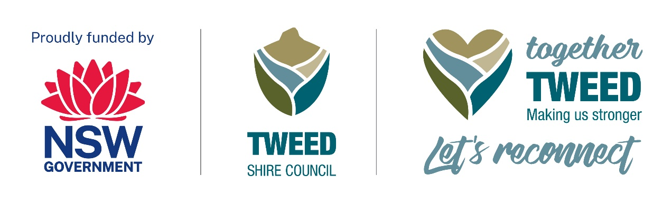A Tiny Taste of Tyalgum
Saturday 20 January 2024: 11am to 11pm

Event accessibility
A Tiny Taste of Tyalgum is a free community event designed to showcase local businesses and reignite tourism while celebrating the positive connection through live music, art, poetry and dance.
We are dedicated to making A Tiny Taste of Tyalgum accessible and inclusive for all attendees.
This document provides information about the accessible features available, to ensure that everyone can participate and enjoy the event.

Access services
Break Out Spaces: Designated break-out spaces will be provided for individuals who may need a quiet and comfortable area.
Accessible toilets: A permanent facility is located on Coolman Street next to the tennis court. A temporary facility will also be located on the Oval.
Assistance Animals: Service animals are welcome at the event. Water bowls will be available on request.
Marshalls or volunteers will be available to assist with any questions or mobility needs. Look for them at key locations such as the main entry and information booth.
A site map will be available in hardcopies on the day. You can also access it through the event's website (details below). Marshalls will be available to assist if needed.
Camping at the grounds next to the Oval is available. All information is on the event website.

Getting here
Tiny Taste of Tyalgum is located on Coolman Street in Tyalgum at the Community Hall and Sports Oval across the road from the Hall.
Transport: A free minibus service will run regularly between Murwillumbah, Chillingham and Tyalgum, throughout the event. This minibus can accommodate 12 passengers, however, is not accessible for wheelchairs. Information about designated bus collection points will be available on the event website (details below).
Drop-off Points: Convenient drop-off points will be located at the Community Hall and will be clearly sign-posted. Volunteers/marshals will be available to assist at these locations.
Accessible Parking: Accessible parking spaces will be located at the side of the Hall, marked for easy identification. No time limits apply to parking.
Street Access: Event areas will be accessible via well-maintained, accessible streets.

Mobility
Stairs and Ramps: Where applicable, ramps will be provided for accessibility. Stairs will be clearly marked, and alternative step-free routes will be available. Matting will be available over some grassed areas to create an accessible viewing area on the oval.
Wheelchair Access: The Hall is wheelchair accessible, with smooth and level surfaces. This area is sheltered.
Accessible Toilets: Three accessible toilets are available in the following locations:
- on the Oval near the viewing area,
- in the local park next to the Oval, and
- in the Community Hall.
Assistance Animals: Service animals are welcome at the event. Water bowls will be available on request.

Accessible seating
Designated Accessible Seating Areas: These are provided on the Oval and Community Hall to offer an inclusive experience with an unobstructed view of the stages and performances.
Wheelchair Positions: Purposefully situated at both the Hall and the Oval, wheelchair spaces offer unobstructed views for an enriched event experience.
Diverse Seating Options: Enjoy a variety of seating choices, from chairs with armrests to those without, designed to cater to different preferences and ensure maximum comfort.

Access enquiries
For any access-related inquiries or to request specific accommodations, please contact Louise Vanderdonk at:
• Phone: 0447 187 347
• Email: atinytasteoftyalgum@gmail.com
• Website: www.atinytasteoftyalgum.com
We are here to ensure that your experience at A Tiny Taste of Tyalgum is enjoyable and accessible for everyone.

Together Tweed: Let's Reconnect Program:
Please use this link to Tweed Shire Council’s webpage for information - Together Tweed: Let’s Reconnect | Tweed Shire Council (nsw.gov.au)

