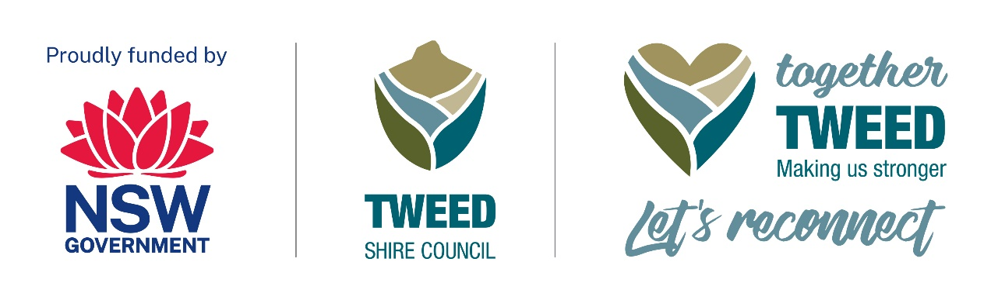 A Tiny Taste of Tyalgum

About the event
Saturday 20 January 2024 from 11.00am to 11.00pm.
A Tiny Taste of Tyalgum is a free community event designed to showcase local businesses and reignite tourism while celebrating the positive connection through live music, art, poetry and a bush dance.
Free activities for children will be held in the Community Hall and at the Oval and the Tweed Regional Museum on Wheels will be located at the Community Hall.
A Tiny Taste of Tyalgum event accessibility details are available as a word document on Tweed Shire Council’s ‘Together Tweed: Let’s Reconnect’ webpage under the ‘Event accessibility’ heading (please access using the following link): Together Tweed: Let’s Reconnect | Tweed Shire Council (nsw.gov.au)

Event location
Coolman Street in Tyalgum at the Community Hall and Sports Oval across the road from the Hall.

Event contact details
For enquiries, please contact Louise Vanderdonk at:
• Phone: 0447 187 347
• Email: atinytasteoftyalgum@gmail.com
• Website: www.atinytasteoftyalgum.com
We are here to ensure that your experience at A Tiny Taste of Tyalgum is enjoyable and accessible for everyone.

Event schedule
11.00am – Opening and Acknowledgement of Country on the Oval.
Throughout - activities include live music on the Oval, poetry and art exhibition and activities for children in the Hall. Here are some highlights of our line-up:
Dimmer Indiana is your go-to young and fun band ready to set the stage ablaze!. With a playful twist on traditional rock, they seamlessly blend in elements of funk and rap, creating a sound that's as lively as their spirit.
Round Mountain Girls is a band that seamlessly blends the nostalgic tones of '80s music with the rustic charm of bluegrass and country. Led by a lineup boasting the harmonious twang of fiddle, banjo, mandolin, bass, guitar, and percussion, their music is a delightful fusion of genres that transports listeners through time and space.
Hoopla Circus is the extraordinary circus school led by the charismatic Suzie Cardiff. Brace yourselves for a day filled with joy, laughter, and awe-inspiring activities as Hoopla Circus brings their magical touch to this special event.
Vivian Bubbles is a vivacious lady whose sole mission is to sprinkle joy and laughter into the lives of children. Vivian will turn little faces into works of art with her vibrant palette and is also the maestro of bubbles - creating iridescent dreams that float through the air, leaving a trail of awe and giggles in their wake.
5.30pm - Rantan Aussie Bush Band
The iconic Rantan Bush Band has been a trailblazer in Australian bush and country music. The band's lineup features Alan on vocals, guitar, sax, fiddle, and more, while Robyn serves as the dance caller and percussionist. Bob Hall, a skilled lead guitarist, adds his talent with mandolin and banjo. Rantan continues to charm audiences with their diverse repertoire, from bush dances to pop and rock hits.
11.00pm – event close.
An event program with further details will be available via the event website.

Together Tweed: Let’s Reconnect program
Please use this link to Tweed Shire Council’s webpage for information about other events - Together Tweed: Let’s Reconnect | Tweed Shire Council (nsw.gov.au)

